# **Week_3 Report**

**Data:**

From MondoDB we have extracted the collected data in .csv format.

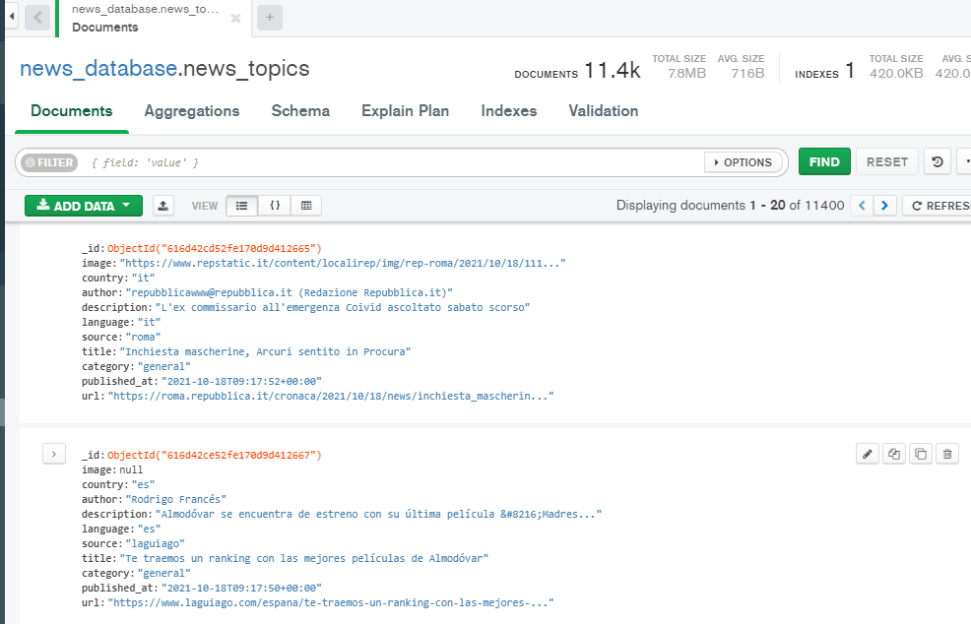

Excel data:

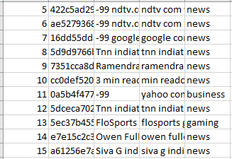

**Model creation:**

* Data loading: Reading the CSV file.

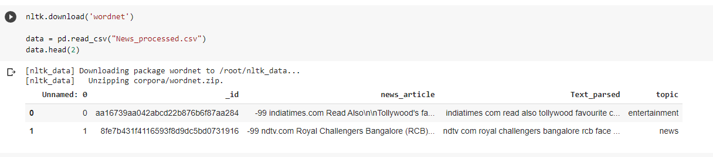

* Removing the nulls from the data.

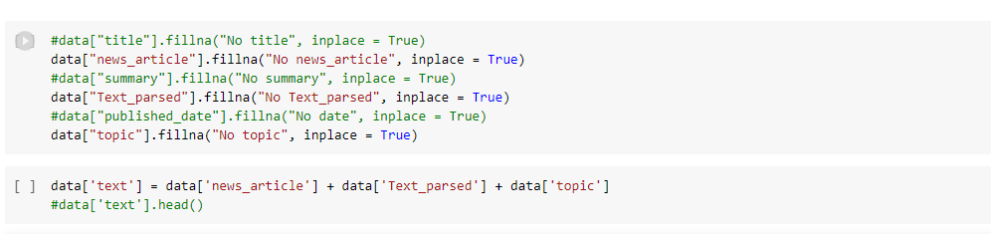

* Processing the data

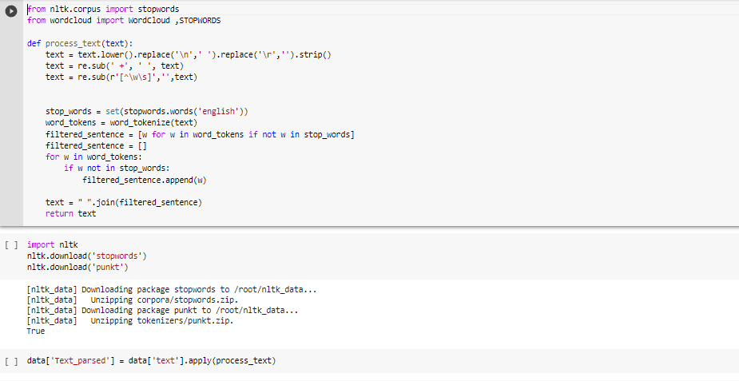

* Label Encoding

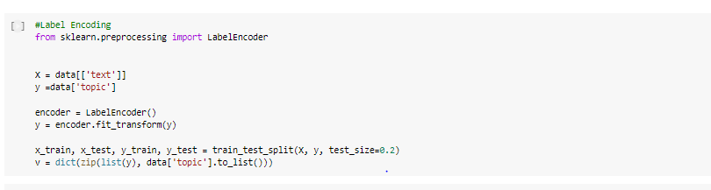

* **Training the model:**

Trained the model using MultinomialNB classifier

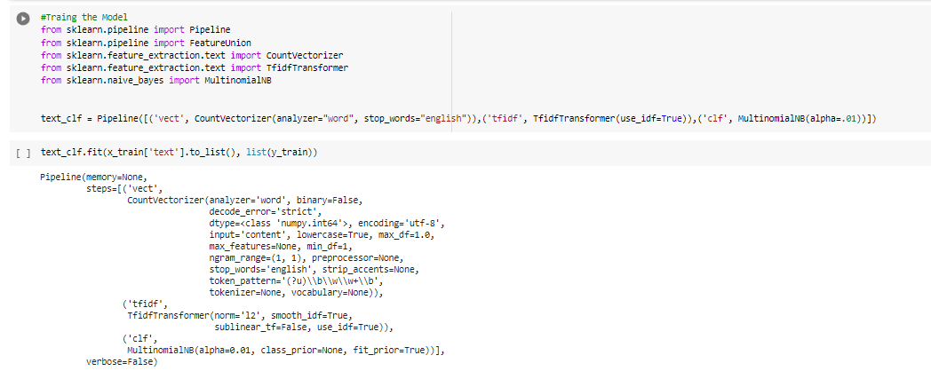

* **Accuracy: 70%**

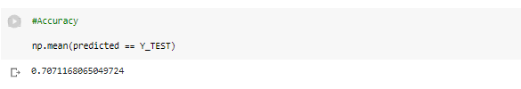

* **Predictions:**

When we give the News in the docs_news we get the predictions what category the news belongs to.

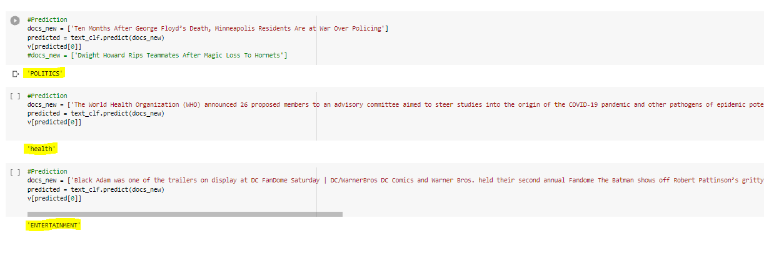

**Challenges Faced:**

* While converting the .ipynb file to .py and running in the local environment facing a few python package compatibility issues which we are still trying to resolve.